**MongoDB wk5**

**Question 5.1:** Download the week5.js file and place it into the week5 folder

vagrant@precise64:~/mongotraining/week5$ ls

week5.js

vagrant@precise64:~/mongotraining/week5$ mongo --shell localhost/week5 week5.js

MongoDB shell version: 2.4.5

connecting to: localhost/week5

type "help" for help

> homework.init()

{ "n" : 0, "connectionId" : 1, "err" : null, "ok" : 1 }

still working...

{

"updatedExisting" : true,

"n" : 20000,

"connectionId" : 1,

"err" : null,

"ok" : 1

}

count: 20000

> db.sensor_readings.find( {

... tstamp : {

... $gte : ISODate("2012-08-01"),

... $lte : ISODate("2012-09-01")

... },

... active : true

... } ).limit(3)

{ "_id" : 847, "active" : true, "str" : "this is a test", "tstamp" : ISODate("2012-08-11T00:00:00Z"), "x" : 99 }

{ "_id" : 1771, "active" : true, "str" : "this is a test", "tstamp" : ISODate("2012-08-17T00:00:00Z"), "x" : 99 }

{ "_id" : 2695, "active" : true, "str" : "this is a test", "tstamp" : ISODate("2012-08-23T00:00:00Z"), "x" : 99 }

>db.sensor_readings.find( { tstamp : { $gte : ISODate("2012-08-01"), $lte : ISODate("2012-09-01") }, active : true } ).limit(3).explain()

{

"cursor" : "BasicCursor",

"isMultiKey" : false,

"n" : 3,

"nscannedObjects" : 2696,

"nscanned" : 2696,

"nscannedObjectsAllPlans" : 2696,

"nscannedAllPlans" : 2696,

"scanAndOrder" : false,

"indexOnly" : false,

"nYields" : 0,

"nChunkSkips" : 0,

"millis" : 0,

"indexBounds" : {

},

"server" : "precise64:27017"

}

Create an index to speed up the search

db.sensor_readings.ensureIndex( { tstamp: 1} )

**>** db.sensor_readings.ensureIndex( { tstamp: 1} )

**>** db.sensor_readings.find( { tstamp : { $gte : ISODate("2012-08-01"), $lte : ISODate("2012-09-01") }, active : true } ).limit(3).explain()

{

"cursor" : "BtreeCursor tstamp_1",

"isMultiKey" : false,

"n" : 3,

"nscannedObjects" : 262,

"nscanned" : 262,

"nscannedObjectsAllPlans" : 523,

"nscannedAllPlans" : 523,

"scanAndOrder" : false,

"indexOnly" : false,

"nYields" : 0,

"nChunkSkips" : 0,

"millis" : 0,

"indexBounds" : {

"tstamp" : [

[

ISODate("2012-08-01T00:00:00Z"),

ISODate("2012-09-01T00:00:00Z")

]

]

},

"server" : "precise64:27017"

}

**>** homework.a()

that's a big improvement over table scan -- 262 keys scanned,

but we can do better, try something else / try again.

So, I tried again with db.sensor_readings.ensureIndex( { tstamp: 1, active: true} )

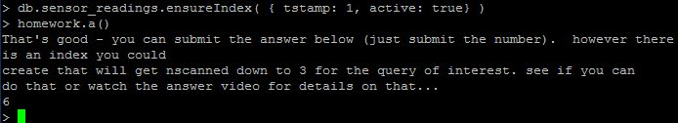

**Question 5.2**

In a mongo shell run homework.b(). This will run in an infinite loop printing some output as it runs various statements against the server.

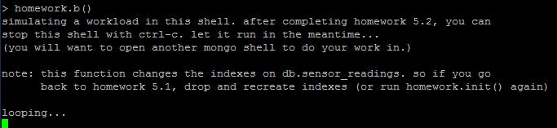

Finding the running app causing slowness will require the db.currentOp() call

<http://docs.mongodb.org/manual/reference/method/db.currentOp/>

From the videos, we can try to locate the slow op via

**>** db.currentOp().inprog.forEach( function(op) { if( op.secs_running >= 0 ) { print("slow op in progress? secs:" + op.secs_running + " opid:" + op.opid); } } )

If we run the script multiple times, we see a repeated opid – this is our culprit so let’s kill it!!!

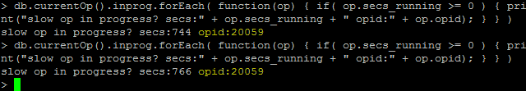

We run the command db.killOp(20059). When we run the script looking for a slow opid again, there is no data returned. We’ve found and killed it successfully.

**Here is the entire work-thru for 5.2**

vagrant@precise64:~/mongotraining/week5$ mongo --shell localhost/week5 week5.js

MongoDB shell version: 2.4.5

connecting to: localhost/week5

type "help" for help

> db.currentOp().inprog.forEach( function(op) { if( op.secs_running >= 0 ) { print("slow op in progress? secs:" + op.secs_running + " opid:" + op.opid); } } )

slow op in progress? secs:744 opid:20059

> db.currentOp().inprog.forEach( function(op) { if( op.secs_running >= 0 ) { print("slow op in progress? secs:" + op.secs_running + " opid:" + op.opid); } } )

slow op in progress? secs:766 opid:20059

> db.killOp(20059)

{ "info" : "attempting to kill op" }

> db.currentOp().inprog.forEach( function(op) { if( op.secs_running >= 0 ) { print("slow op in progress? secs:" + op.secs_running + " opid:" + op.opid); } } )

> homework.c()

12

**Question 5.3**

Compact the week5.sensor_readings collection. Then run homework.d() and enter the result below.

**>** db.runCommand ( { compact: 'sensor_readings'} )

{ "ok" : 1 }

> homework.d()

21

I also found that, if I ran a command such as the one here, I received an incorrect answer for this homework

> db.runCommand ( { compact: 'sensor_readings', paddingFactor: 1.1 } )

{ "ok" : 1 }

**See incorrect answer here**

> homework.d()

23